**Hospital Management System – Needs W.r.t Application Stability**

* Key resource for any organisation is: **Compute, Storage, Networking and Database.**
* The architecture of management System is as follows  
  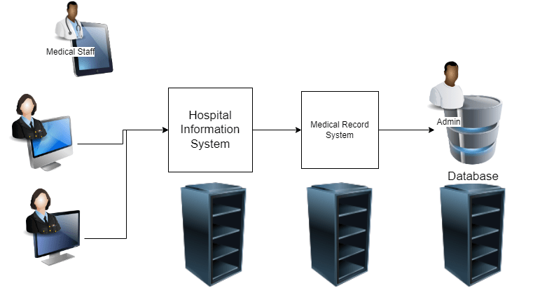
* Your organization qtinfosystems is maintaining this system for 100 hospitals
* Now let’s try to figure out some failures
  + Network failures
  + Hardware failures
  + Application failures
* You are assigned to figure out failures. To solve these issues, we will figure out a **pro-active** approach
  + For every 1 minute
    - check if every server is responding or not
    - Check if application is responding or not
  + Alert if the servers/applications are not responding
* Log is a record which specifies some activity done
  + Operating systems have logs, we might need to finetune it
    - Windows => event viewer
    - Linux => Syslog
  + Applications also log, try to understand about failure from there
* Tracing is an approach to figure out the flow in your system
* Every system has resource utilization information
  + cpu
  + memory
  + disk
  + network
* Metrics are values which represent some information about system/application with value as number with time dimension
* QT Info System needs a Monitoring Solution.
* Observability is what QT Info System needs i.e. they need to get
  + logs
  + metrics
  + traces
* MTTR (Mean Time to Recover) this refers to average time taken by your organization to recover from failures.
* MTTF (Mean Time to Fail): This refers to average time during the certain to get an failure in your system
* SLA (Service Level Agreement): This is an agreement between service provider and customer w.r.t to availability and other important metrics

**Key Terms:**

1. active vs proactive approach
2. trace: detailed information.